AUTHOR GUIDELINES FOR ICAD 2021 PROCEEDINGS MANUSRIPTS
Author 1 | Author 2
Organization,  Address line 2,  City, Country  author1@example.com | Organization,  Address line 2,  City, Country  author2@example.com

ABSTRACT
This is the template file for the proceedings of the 2022 International Conference on Auditory Display, which will be held June 30–July 4, 2025, in Coimbra, Portugal. This template has been generated from the ICAD2018 template and aims at producing conference proceedings in electronic form. Please use either LaTeX or Microsoft Word formats when preparing your submission. All questions concerning ICAD2025 submissions should be addressed to the paper chairs (info.icad@dei.uc.pt). These guidelines and templates are modified from those for earlier ICAD conferences, so an experienced author who has published something in these conferences/workshops will find it easy to follow the guidelines and use the templates. The templates are available in electronic form at the website: https://icad2025.icad.org/ The length of the abstract should be approximately 150 words.

INTRODUCTION
The guidelines given below, including complete descriptions of the fonts, spacing, and related information for producing your proceedings manuscripts, are critical to produce the ICAD 2022 proceedings with a more uniform look. If you have any questions, please email them to the paper chair.

FORMATTING YOUR PAPER
All manuscripts must be formatted for white A4 paper (8.27 in × 11.02 in). Please do not use US letter-size papers. All printed material, including text, illustrations, and charts, must be kept within a print area of 6.27 inches (169 mm) wide by 9.2 inches (233 mm) high. Do not write or print anything outside the print area. The top margin must be 1 inch (25 mm), except for the title page, and the left margin must be 0.75 inch (19 mm). All text must be in a two-column format. Columns are to be 3.29 inches (83.5 mm) wide, with a 0.3 inch (8 mm) space between them. Text must be fully justified.

PAGE TITLE SECTION
The paper title (on the first page) should begin 1 inch (25.4 mm) from the top edge of the page, centered, completely capitalized, and in Times 14-point, boldface type. The authors' name(s) and affiliation(s) appear below the title in capital and lower-case letters. Papers with multiple authors and affiliations may require two or more lines for this information.

TYPE-STYLE AND FONTS
To achieve the best rendering in the proceedings, we strongly encourage you to use Times-Roman font. In addition, this will give the proceedings a more uniform look. Use a font that is no smaller than nine-point type throughout the paper, including figure captions.
In nine-point type font, capital letters are 2 mm high. If you use the smallest point size, there should be no more than 3.2 lines/cm (8 lines/inch) vertically. This is a minimum spacing; 2.75 lines/cm (7 lines/inch) will make the paper much more readable. Larger type sizes require correspondingly larger vertical spacing. Please do not double-space your paper. True-Type 1 fonts are preferred.
The first paragraph in each section should not be indented, but all the following paragraphs within the section should be indented as these paragraphs demonstrate.

MAJOR HEADINGS
Major headings, for example, “1. Introduction”, should appear all capital letters, bold face, if possible, centered in the column, with one blank line before, and one blank line after. Use a period (“.”) after the heading number, not a colon.

Subheadings
Subheadings should appear in lower case (initial word capitalized) in boldface. They should start at the left margin on a separate line.

Sub-subheadings
Sub-subheadings, as in this paragraph, are discouraged. However, if you must use them, they should appear in lower case (initial word capitalized) and start at the left margin on a separate line, with paragraph text beginning on the following line. They should be in italics.

PAGE NUMBERING, HEADER, AND FOOTER
Please do not paginate your paper. Page numbers, session numbers, and conference identification will be inserted when the paper is included in the proceedings. In addition, please do not change and remove the header and footer.

ILLUSTRATIONS, GRAPHS, AND PHOTOGRAPHS
Illustrations must appear within the designated margins. They may span the two columns. If possible, position illustrations at the top of columns, rather than in the middle or at the bottom. Caption and number every illustration. All halftone illustrations must be clear black and white prints. Colors may be used, but they should be selected so as to be readable when printed on a black-only printer.
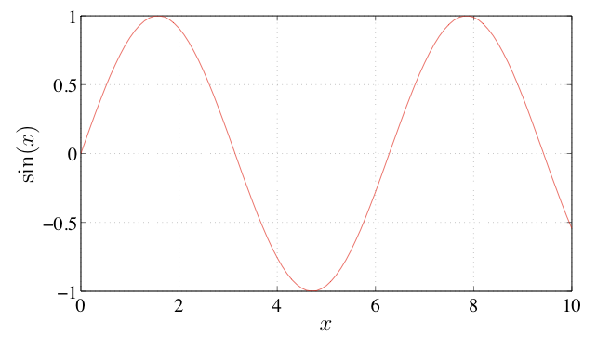
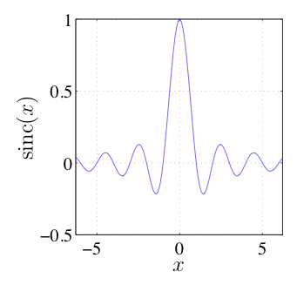
Figure 1: Example of placing a figure with experimental results.

EQUATIONS
Equations should be placed on separate lines and consecutively numbered with equation numbers in parentheses flush with the right margin, as illustrated in (1) that gives the homogeneous acoustic wave equation in Cartesian coordinates [1], where p(x,y,z,t) is an infinitesimal variation of acoustic pressure from its equilibrium value at position (x, y, z) and time t, and where c denotes the speed of sound.

$∇^{2}p(x,y,z,t)−\frac{1}{c^{2}}\frac{∂^{2}p(x,y,z,t)}{∂t^{2}}=0,$ (1)
Symbols in your equation should be defined before the equation appears or immediately following. Use (1), not Eq. (1) or equation (1), except at the beginning of a sentence: “Equation (1) is ...”

FOOTNOTES
Use footnotes sparingly (or not at all!) and place them at the bottom of the column on the page on which they are referenced. Use Times 9-point type, single-spaced. To help your readers, avoid using footnotes altogether and include necessary peripheral observations in the text (within parentheses, if you prefer, as in this sentence).

REFERENCES
List and number all bibliographical references at the end of the paper. The references should be numbered in order of appearance in the document. When referring to them in the text, type the corresponding reference number in square brackets as shown at the end of this sentence [2], [3]. For LATEX users, the use of the BibTEX style file IEEEtran.bst is recommended, which is included in the LATEX paper kit available from the conference website [4].

ACKNOWLEDGMENT
The preferred spelling of the word acknowledgment in America is without an “e” after the “g.” Try to avoid the stilted expression, “One of us (R. B. G.) thanks ...” Instead, try “R.B.G. thanks ...” Put sponsor acknowledgments in the unnumbered footnote on the first page.

REFERENCES
- E. G. Williams, Fourier Acoustics: Sound Radiation and Nearfield Acoustic Holography, London, UK: Academic Press, 1999.
- A. Bee, C. Player, and X. Lastname, “A correct citiation,” in Proc. of the 1st Int. Conf. (IC), London, UK, 2001, pp. 1119-1134.
- M. Smith, “A good journal article,” J. Acoustical Soc. Am., vol. 110, no. 3, pp. 1598-1608, March 2001.
- http://www.icad.org

